Exercise

1)

i) State the null and alternative hypotheses for the test

H0: The customers choose the four snack types (A, B, C, D) with equal probability (pA​=pB​=pC​=pD​=0.25).

Ha: At least one snack type has a probability of purchase different from 0.25.

ii) Perform a suitable chi-squared test to test the null hypothesis.

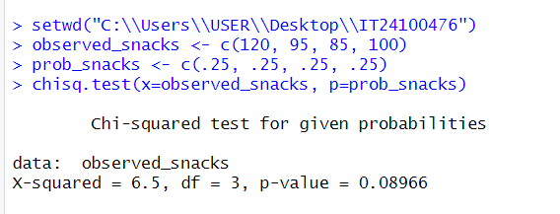

iii) Give your conclusions based on the results.

**Conclusion:** Since the p-value (0.08966) is greater than 0.05, we do not reject the null hypothesis at the 5% level of significance. Therefore, there is not enough statistical evidence to conclude that the snack types are chosen with different probabilities, the data is consistent with the owner's claim of equal customer preference for the four snack types.